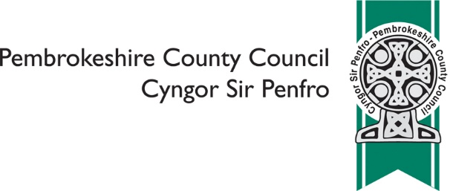

Review of education provision at Ysgol y Preseli
and its cluster schools – RESPONSE FORM

Tell us your thoughts on maintaining sustainable education provision in the Preseli cluster e.g. in the form of federation arrangements between schools

Recruitment and retention of head teachers for small schools can be challenging, please tell us your thoughts and ideas about this e.g. in the form of federation arrangements between schools

Tell us your ideas about provision for Additional Learning / Behavioural Needs through the medium of Welsh

Please use this space to tell us about any other ideas for change you can suggest

 | Please tell us what your interest in the consultation is? (please tick all that apply)
 | ❑ | Ysgol y Preseli
 | ❑ | Ysgol y Frenni
 | ❑ | Ysgol Clydau
 | ❑ | Ysgol Eglwyswrw
 | ❑ | Ysgol Maenclochog
 | ❑ | Ysgol Brynconin
 | ❑ | Ysgol Cilgerran
 | ❑ | Ysgol Llandudoch
 | ❑ | Ysgol Hafan y Môr
 | ❑ | Narberth CP
 | ❑ | Pre-school Parent
 | ❑ | Parent
 | ❑ | Staff
 | ❑ | Governor
 | ❑ | Local resident
 | ❑ | Elected member
 | Other, please specify ………………………………………………………………………………..
 | Are you? (please tick only one)
 | ❑ | Aged 16 or under
 | ❑ | Aged 17 - 24
 | ❑ | Aged 25 - 64
 | ❑ | Aged 65 or over
 | ❑ | Prefer not to say

 | What is your first language? (please tick only one)
 | ❑ | Welsh
 | ❑ | English
 | ❑ | Prefer not to say
 | Other (please specify) ………………………………………………………………………………
 | Are your day to day activities limited by an illness or condition that has lasted, or is expected to last, for 12 months or more? (please tick only one)
 | ❑ | Yes
 | ❑ | No
 | ❑ | Prefer not to say

 | Do you provide care for someone (aged 19 or under) whose day to day activities are limited by an illness or condition that has lasted, or is expected to last, for 12 months or more? (please tick only one)
 | ❑ | Yes
 | ❑ | No
 | ❑ | Prefer not to say

 | What is your religion? (please tick only one)
 | ❑ | No religion
 | ❑ | Christian (all denominations)
 | ❑ | Buddhist
 | ❑ | Hindu
 | ❑ | Jewish
 | ❑ | Muslim
 | ❑ | Sikh
 | ❑ | Prefer not to say
 | Other, please specify ……....................................................................................................

Once complete, please return to surveys@pembrokeshire.gov.uk or Director for
Children & Schools, Pembrokeshire County Council, County Hall, Haverfordwest,
SA61 1TP

Preliminary engagement starts 3rd June 2019 and ends 5th July 2019

