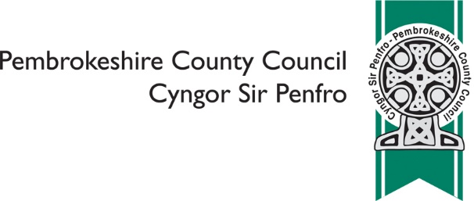

COUNTY FARM ESTATE

Pembrokeshire County Council manages approximately 5,500 acres of farmland across the County, made up of 44 equipped farms with accommodation and farm buildings, as well as bare land and grazing land. Usage is mixed across the estate and is made up of a mix of beef, horticulture and dairy farms.

The Council is currently undertaking a review of its County Farm Estate Policy, which was last considered in 2016. A task and finish group consisting of five Councillors will be considering a range of information and, as part of this, we would like your views on what we currently do and whether there are any improvements we can make.

 | In what capacity are you responding to this consultation? (please tick one)
 | ❑ | I'm a tenant farmer on the Council Farm Estate
 | ❑ | I'm interested in becoming a tenant farmer on the Council Farm Estate
 | ❑ | I'm a County Councillor
 | ❑ | I'm a Town or Community Councillor
 | ❑ | I represent a business
 | ❑ | I represent a voluntary sector organisation
 | ❑ | I represent a public sector organisation
 | ❑ | I'm an interested resident
 | Other, please specify ………………………………………………………………
If you are responding on behalf of a business or organisation, please provide details below:
Name of organisation
Your name
Your position

 | Is this response the official response of your organisation? (please tick only one)
 | ❑ | Yes
 | ❑ | No

 | What do you think is an important part of the Council maintaining a county farm estate? (please tick all that apply)
 | ❑ | To enable people to get into farming
 | ❑ | To get an income from the estate
 | ❑ | To support the rural economy
 | ❑ | To increase biodiversity and environmental benefits
 | ❑ | All of the above
 | Other, please explain …………………………………………………………
 | What do you think are the benefits of the farm estate? (please tick all that apply)
 | ❑ | Providing opportunities to get into farming
 | ❑ | Providing employment in rural areas
 | ❑ | Providing a financial benefit to the Council
 | Other, please explain …………………………………………………………
 | The majority of our farm tenancies last for a period of 6 years. Do you think that this is:
 | ❑ | Too long
 | ❑ | Too short
 | ❑ | About right

 | We currently have 5 'starter' farms (less than 50 acres). Do you think this number should be increased?
 | ❑ | Yes
 | ❑ | No
 | ❑ | Don't know
 | Comments
 | How do you think county farms could diversify to provide benefits to tenants, the Council and the environment?

Is there anything you think we should do to provide more employment opportunities through the farm estate?

Do you have any thoughts on how the Local Authority could increase the financial performance of the farm estate?

Is there anything we should do to improve the farm estate? (please use this section to make any further suggestions / comments not included in the questions above)

You are asked to provide email and postal address details only if you wish to receive a copy of the Consultation Report
Name
Email
Address

All information will be handled in accordance with the Data Protection Act 2018

Once complete, please return to surveys@pembrokeshire.gov.uk or post to: Pembrokeshire County Council, Policy, 2D County Hall, Haverfordwest, SA61 1TP

Please respond by Tuesday 24th September 2019

