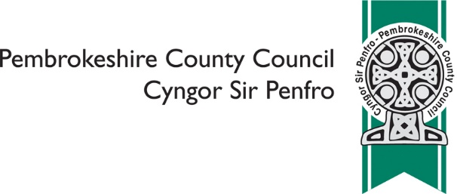

Amalgamation of Ysgol y Frenni and Ysgol y Preseli to form a 3-19 Welsh-medium School in Crymych / Uno Ysgol y Frenni ac Ysgol y Preseli er Mwyn Ffurfio Ysgol Cyfrwng Cymraeg 3 - 19 yng Nghrymych

Please indicate which of the of the following reflects your views on
the proposal: to discontinue Ysgol y Preseli and Ysgol y Frenni and
to establish a new 3 - 19 Welsh-medium school using both school sites

 | ❑ | I do not feel strongly one way or the other
 | ❑ | I support the proposal
 | ❑ | I do not support the proposal

Please provide any alternatives you have to the Council's proposal

Please provide any other comments on the proposal

Please tell us what your interest in the consultation is
(please tick all that apply)
 | ❑ | Pre-school parent
 | ❑ | Staff
 | ❑ | Parent
 | ❑ | Governor
 | ❑ | Local resident
 | ❑ | Ysgol y Frenni
 | ❑ | Ysgol y Preseli
 | ❑ | Ysgol Llandudoch
 | ❑ | Ysgol Cilgerran
 | ❑ | Ysgol Eglwyswrw
 | ❑ | Ysgol Clydau
 | ❑ | Ysgol Maenclochog
 | ❑ | Ysgol Brynconin
 | ❑ | Ysgol Hafan y Môr
 | ❑ | Narberth CP
 | ❑ | Ysgol Portfield
 | ❑ | Ysgol Caer Elen

 | Other
 | Are you?
 | ❑ | Aged 16 or under
 | ❑ | Aged 17 - 24
 | ❑ | Aged 25 - 64
 | ❑ | Aged 65 or over
 | ❑ | Prefer not to say

 | In which language do you prefer to communicate?
 | ❑ | English
 | ❑ | Welsh
 | ❑ | Prefer not to say

 | Other
Are your day to day activities limited by an illness or condition that has lasted,
or is expected to last, for 12 months or more?
 | ❑ | Yes
 | ❑ | No
 | ❑ | Prefer not to say

Do you provide care for someone (aged 19 or under) whose day to day
activities are limited by an illness or condition that has lasted, or is expected
to last, for 12 months or more?
 | ❑ | Yes
 | ❑ | No
 | ❑ | Prefer not to say

 | What is your religion?
 | ❑ | No religion
 | ❑ | Christian (all denominations)
 | ❑ | Buddhist
 | ❑ | Hindu
 | ❑ | Jewish
 | ❑ | Muslim
 | ❑ | Sikh
 | ❑ | Prefer not to say

 | Other, please specify
 | Do you wish to be informed of the publication of the Consultation Report?
 | ❑ | Yes
 | ❑ | No

You are asked to provide email and postal address details ONLY if you wish to receive a
copy of the Consultation Report. Other information you are asked to provide is for purposes
of Equalities Monitoring and will be used for statistical purposes only.

Name
Email
Address

We will make your comments publically available as part of the Consultation
Report, unless you are asked not to

 | ❑ | I am happy for you to make comments publically available
 | ❑ | I am NOT happy for you to make any comments publically available

All information will be handled in accordance with the Data Protection Act 2018

Once complete please return to surveys@pembrokeshire.gov.uk or post to
Chief Education Officer, Pembrokeshire County Council, County Hall,
Haverfordwest, SA61 1TP

The closing date for responses is 5pm on Wednesday 15th April 2020

