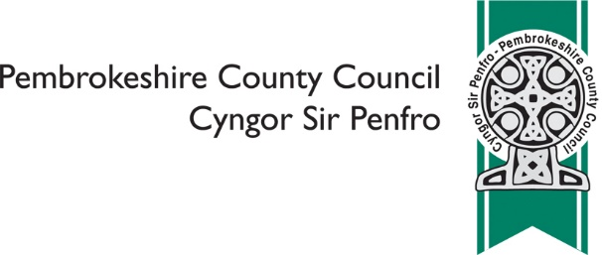
Establishment of a new 3-11 Welsh Medium
Primary School in the Pembroke area

Please indicate which of the of the following reflects your views on the
proposal to establish a new Welsh medium primary school in Pembroke

 |  |  |  | ❑ | I do not feel strongly one way or the other
 |  |  |  | ❑ | I support the proposal
 |  |  |  | ❑ | I do not support the proposal

Please provide your comments on the proposal regarding Welsh medium
primary provision in the Pembroke area

Please provide any alternatives you have to the Council’s proposal

 | Please tell us what your interest in the consultation is? (please tick all that apply)
 | ❑ | Pre-school parent
 | ❑ | Staff
 | ❑ | Parent
 | ❑ | Governor
 | ❑ | Local resident
 | ❑ | Ysgol Gelli Aur / Golden Grove
 | ❑ | Penrhyn VC School
 | ❑ | Monkton Priory Community School
 | ❑ | Lamphey CP School
 | ❑ | Cosheston VC School
 | ❑ | Pembroke Dock Community School
 | ❑ | Pennar Community School
 | ❑ | Ysgol Caer Elen
 | ❑ | Ysgol y Preseli
 | ❑ | Ysgol Harri Tudur / Henry Tudor School
 | Other ………………………………………………………………………………………
 | Are you?
 | ❑ | Aged 16 or under
 | ❑ | Aged 17 - 24
 | ❑ | Aged 25 - 64
 | ❑ | Aged 65 or over
 | ❑ | Prefer not to say

 | In which language do you prefer to communicate?
 | ❑ |  | English
 | ❑ |  | Welsh
 | ❑ |  | Prefer not to say
 | Other …………………………………………………….
Are your day to day activities limited by an illness or condition that has
lasted, or is expected to last, for 12 months or more?
 | ❑ | Yes
 | ❑ | No
 | ❑ | Prefer not to say

Do you provide care for someone (aged 19 or under) whose day to day
activities are limited by an illness or condition that has lasted, or is
expected to last, for 12 months or more?
 | ❑ | Yes
 | ❑ | No
 | ❑ | Prefer not to say

 | What is your religion?
 | ❑ | No religion
 | ❑ | Christian (all denominations)
 | ❑ | Buddhist
 | ❑ | Hindu
 | ❑ | Jewish
 | ❑ | Muslim
 | ❑ | Sikh
 | ❑ | Prefer not to say
 | Other, please specify ………………………………………………………………………….
 | Do you wish to be informed of the publication of the Consultation Report?
 | ❑ | Yes
 | ❑ | No

You are asked to provide email and postal address details ONLY if you wish to receive a
copy of the Consultation Report. Other information you are asked to provide is for
purposes of Equalities Monitoring and will be used for statistical purposes only.

Name
Email
Address

We will make your comments publically available as part of the Consultation
Report, unless you are asked not to
 | ❑ | I am happy for your to make comments publically available
 | ❑ | I am NOT happy for you to make any comments publically available

All information will be handled in accordance with the Data Protection Act 2018

Once complete, please email to surveys@pembrokeshire.gov.uk or post to
Director for Children & Schools, Pembrokeshire County Council, County Hall,
Haverfordwest SA61 1TP

The deadline for responses is Tuesday 31st December 2019

