Draft Toilet Strategy  Consultation | 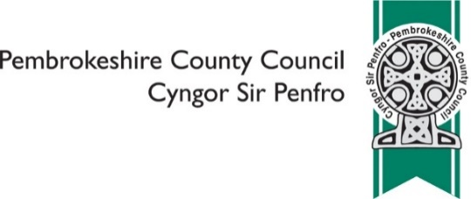

We aim to provide accessible, clean toilets in the most appropriate locations.
There is no requirement for councils to provide public toilets although historically many councils have chosen to do so. Over the past few years the number of traditional public toilets provided or funded by councils across the UK has significantly decreased. Another trend is that some traditional public toilets are now managed and/or maintained by local communities.
We currently provide many more public toilets than the Welsh average. Through a contract we provide 72 of these: 52 have disabled facilities, one has an adult changing place facility and 19 have baby changing facilities.
We have reduced the number of traditional public toilets that we provide in 2014. Our strategy was to encourage community groups or Town and Community Councils to take these on, and as a result, the cost of running 15 traditional public toilets was taken on by local community groups. Also some private businesses whilst not advertising their facilities as public toilets, do allow the general public to use them without making a purchase.
In association with our contractor Danfo UK Ltd, we have been able to carry out several large-scale capital investments recently. In 2017 the Saundersfoot Regency car park toilet block was knocked down and rebuilt to provide a state of the art facility. In 2018 the toilets at Tenby the Green where renovated to include our first Adult Changing facility located at a public toilet block. Our plans for investment will continue in 2019 when we will be opening a new toilet block on the Chimneys Link Road development in Fishguard and plans are currently being finalised for a new toilet block in Haverfordwest in place of the multi storey car park facility. In addition there have been a number of small scale enhancements such as roof repairs, new doors and other general maintenance activities.
Pay to use toilets were introduced in phases from July 2015. This has generated an income, which contributes towards the running costs of the toilets, therefore keeping costs down and allowing us to maintain more facilities. Currently ten toilet blocks charge to use. Cashless payments were introduced at all turnstile operated toilets in May 2018 for added customer convenience in acknowledgment that many people do not carry cash with them anymore or have the right change to use the toilets, this will hopefully reduce the damage from theft associated with the coin mechanisms.
There are, however, limitations to what we can achieve. Many of the toilets are in old buildings, which can often make them difficult to maintain and some are in need of significant investment and the current investment fund is very limited. Unfortunately toilets are also a magnet for anti-social behaviour including drug taking and vandalism. This often affects opening hours and in the past has resulted in temporary and permanent closures.
We understand the value of these facilities to communities and through this strategy will be actively looking to retain as much public provision as possible in Pembrokeshire despite the very severe financial reductions faced. The production of this strategy does not mean that all existing provision provided by Pembrokeshire County Council will remain. However, we will take a strategic view across our County on how these facilities can be provided and accessed both now and in the future, through innovative ways of working and collaboration with others
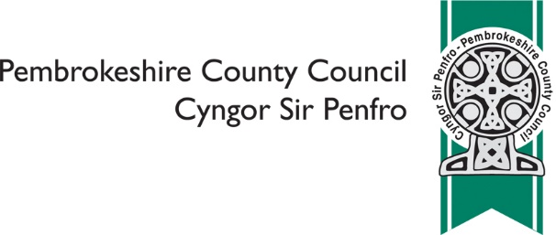
Draft Toilet Strategy Consultation – Response Form
SECTION 1: We aim to secure the future of as many current public toilets as possible. We will do this in a variety of ways:
- We aim to work collaboratively with Town and Community Councils and local communities to protect future provision. This has been a successful model in the past to prevent closures
- We will consider community asset transfers as a way of protecting facilities. This model has also been used in the past to prevent closures
- We will consider increasing charges or including more pay to use facilities. Whilst we acknowledge that comments in general were against charging, there were also comments in contrast to that which suggest that the public would be happy to pay if it resulted in toilets being available
- We will seek to identify alternative provision for toilets at risk of closure. Whilst this strategy does not look to prevent closures where there is a legitimate reason to pursue this, however in all cases we will endeavour to find a suitable alternative to maintain sufficient numbers
- We will consider those that we currently manage and those we maintain, but which do not belong to us to ensure public money is spent in the correct way
Question 1. Please indicate to what extent you agree or disagree with the ways in which we are proposing to secure the future of as many current public toilets as possible? (please tick only one)
Agree Neither Disagree Don’t know / not sure
1a. Please make any comments that you wish to

SECTION 2: We aim to increase access to public toilet provision by:
- Open up suitable public buildings within our control as public toilets including leisure centres, libraries and community centres. Not all buildings will be suitable due to access arrangements and safeguarding, and opening hours will be restricted to the buildings operating hours. Those which are open to the general public will display the national toilet logo
- We will engage with local organisations and businesses to encourage them to open up their toilets for public use – this will help address the current challenges regarding the long-term provision and the number of toilets available. We will also encourage those who agree to open up their toilets to the public to display the national logo
Question 2. Please indicate to what extent you agree or disagree with the ways in which we are proposing to increase access to public toilet provision? (please tick only one)
Agree Neither Disagree Don’t know / not sure
2a. Please make any comments that you wish to

SECTION 3: We aim to improve access to all groups by:
- Reviewing baby change facilities so that where possible provision is available to both males and females. We will seek to increase our number of baby change facilities across the County
- Reviewing current toilet opening hours to ensure they meet the needs of their local communities. However whilst we understand the need to consider work patterns meaning that provision is often required 24 hours a day we also have to consider the issues with vandalism and anti-social behaviour which is more frequent at night time. Several of our toilet blocks are hot spots for vandalism and antisocial behaviour, in these cases amending the opening hours may not be feasible
- Ensuring any new toilet blocks or large-scale renovations will provide unisex provision to maximise the number of cubicles that can be accessed by both males and females, and to cater for transgender and non-binary people
- Ensuring any new disabled facilities or large-scale renovations are compliant with Equality Act requirements. It may not be possible to make physical changes to existing provision however where this is not possible consideration will be given to alterative provision
- We will ensure that the public are aware of where they can find a toilet. This could be through improving signage to toilets where necessary, encouraging all public toilets to display the national toilet logo, ensuring our toilets are mapped in conjunction with Welsh Government on the national toilet map for Wales and providing information on our website. We will also work with a third party who wishes to develop an app for public toilet locations
- We will consult with public on any future changes to help identify barriers, needs and ensure all groups are catered for
Question 3. Please indicate to what extent you agree or disagree with the ways in which we are proposing to increase access to all groups? (please tick only one)
Agree Neither Disagree Don’t know / not sure
3a. Please make any comments that you wish to

SECTION 4: We will prioritise our provision and use the criteria below when considering future closures:
- Usage levels
- Proximity to other alternatives
- Effect on tourism
- Effect on economy
- Frequency of misuse/anti-social behaviour
- Disabled provision
Question 4. Please indicate to what extent you agree or disagree with the ways in which we are proposing to prioritise provision and use the criteria above when considering future closures? (please tick only one)
Agree Neither Disagree Don’t know / not sure
4a. Please make any comments that you wish to

SECTION 5: Other Ideas and Suggestions
Question 5. Please use this space to put forward any other ideas or suggestions that you may have

SECTION 6: ABOUT YOU
https://www.pembrokeshire.gov.uk/equalities/why-do-we-ask-equality-questions
Question 6. Are you? (please tick all that apply)
A Pembrokeshire resident
An individual from outside of Pembrokeshire
A mobile worker (e.g. home carer, post / delivery person, contractor etc)

Question 7. Are you? (please tick only one)
Female Male Prefer another term Prefer not to say

Question 8. Are you? (please tick only one)
24 or under 25 – 64 65 – 74 75 or over Prefer not to say

Question 9. Do you have a physical or mental health condition or illness lasting, or expected to last, for 12 months or more and which reduces your ability to carry out day-to-day activities? (please tick only one)
Yes No Prefer not to say

Question 10. Do you provide regular, unpaid, substantial care for a relative, friend or neighbour who is unable to manage at home without help because of sickness, age or disability? (please tick only one)
Yes No Prefer not to say

Question 11. Please indicate if any of the following apply to you (please tick all that apply)
I am expecting a baby I have had a baby in the last six months
I am currently on maternity leave I am currently on paternity leave
None of these Prefer not to say

Question 12. Do you have dependent children aged 5 or under (on 31st March 2019)?
(please tick only one)
Yes No Prefer not to say

Question 13. If you feel that your response to this survey has been influenced (positively or negatively) because of any of the following: your ethnic origin, gender, age, marital status, sexual orientation, disability, gender reassignment, religious beliefs or non-belief, use of Welsh language, BSL or other languages, nationality or responsibility for any dependents, please give details below:

Thank you for your time

Once complete, please scan in and email to surveys@pembrokeshire.gov.uk

You can also post to: Pembrokeshire County Council, Policy, 2D County Hall, Haverfordwest, SA61 1TP

Please respond by Tuesday 5th March 2019

