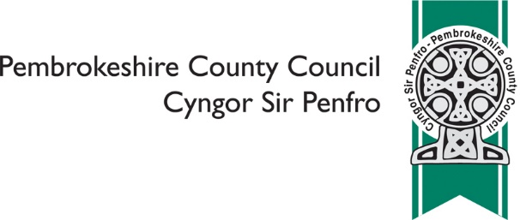

Proposal to Federate Ysgol Gymunedol Brynconin and Ysgol Gymunedol Maenclochog

 | Please indicate which of the following reflects your views on the proposal (please tick only one)
 | ❑ | I do not feel strongly one way or the other
 | ❑ | I support the proposal
 | ❑ | I do not support the proposal

Please provide your comments on the proposal

Please provide any alternatives you have to the proposal

 | Please tell us what your interest in the consultation is? (please tick all that apply)
 | ❑ | Ysgol Gymunedol Brynconin
 | ❑ | Ysgol Gymunedol Maenclochog
 | ❑ | Pre-School Parent
 | ❑ | Staff
 | ❑ | Parent
 | ❑ | Governor
 | ❑ | Local resident
 | Other, please specify
 | _________________________________________________________________

If you feel that your response has been influenced (positively or negatively) because of any of the following: your ethnic origin, sex, age, marital status, sexual orientation, disability, gender reassignment, religious beliefs or non-belief, use of Welsh language, BSL or other languages, nationality or responsibility for any dependents, please give details below:

 | Do you wish to be informed of the publication of the Consultation Report? (please tick only one)
 | ❑ | Yes
 | ❑ | No

You are asked to provide email and postal address details only if you wish to receive a copy of the Consultation Report. Other information you are asked to provide is for the purposes of Equalities Monitoring and will be used for statistical purposes only.
Name

Email

Address

We will make your comments publically available as part of the Consultation Report, unless you ask us not to (please tick only one)
I am happy for you to make my comments publically available
I am NOT happy for you to make any comments publically available

All information will be handled in accordance with the Data Protection Act 1998

Once complete please return to: surveys@pembrokeshire.gov.uk or Pembrokeshire County Council, Policy, 2D County Hall, Haverfordwest, SA61 1TP

Please return by Friday 24th May 2019

