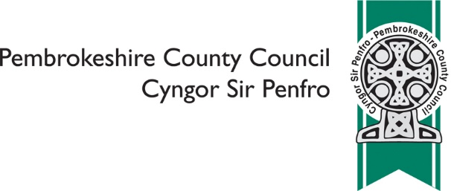
Milford Haven School - Future Proposals for Sixth Form Provision

 | Please indicate which of the of the following reflects your views on the proposal: to make a regulated alternation to Milford Haven School in order to remove its sixth form provision
 | ❑ | I do not feel strongly one way or the other
 | ❑ | I support the proposal
 | ❑ | I do not support the proposal

Please provide any alternatives you have to the Council's proposal

Please provide any suggestions you have on opportunities to develop stronger links with Pembrokeshire College, including the possibility of developing satellite provision

Please provide any other comments on the proposal

 | Please tell us what your interest in the consultation is? (please tick all that apply)
 | ❑ | Pre-school parent
 | ❑ | Staff
 | ❑ | Parent
 | ❑ | Governor
 | ❑ | Local resident
 | ❑ | Milford Haven School
 | ❑ | Milford Haven CP School
 | ❑ | St Francis Catholic School
 | ❑ | Gelliswick VC School
 | ❑ | Coastlands CP School
 | ❑ | Johnston CP School
 | ❑ | Neyland CP School
 | Other

 | Are you?
 | ❑ | Aged 16 or under
 | ❑ | Aged 17 - 24
 | ❑ | Aged 25 - 64
 | ❑ | Aged 65 or over
 | ❑ | Prefer not to say

 | In which language do you prefer to communicate?
 | ❑ | English
 | ❑ | Welsh
 | ❑ | Prefer not to say
 | Other

 | Are your day to day activities limited by an illness or condition that has lasted, or is expected to last, for 12 months or more?
 | ❑ | Yes
 | ❑ | No
 | ❑ | Prefer not to say

 | Do you provide care for someone (aged 19 or under) whose day to day activities are limited by an illness or condition that has lasted, or is expected to last, for 12 months or more?
 | ❑ | Yes
 | ❑ | No
 | ❑ | Prefer not to say

 | What is your religion?
 | ❑ | No religion
 | ❑ | Christian (all denominations)
 | ❑ | Buddhist
 | ❑ | Hindu
 | ❑ | Jewish
 | ❑ | Muslim
 | ❑ | Sikh
 | ❑ | Prefer not to say
 | Other, please specify

 | Do you wish to be informed of the publication of the Consultation Report?
 | ❑ | Yes
 | ❑ | No

You are asked to provide email and postal address details ONLY if you wish to receive a copy of the Consultation Report. Other information you are asked to provide is for purposes of Equalities Monitoring and will be used for statistical purposes only.

Name
Email
Address

 | We will make your comments publically available as part of the Consultation Report, unless you are asked not to
 | ❑ | I am happy for you to make comments publically available
 | ❑ | I am NOT happy for you to make any comments publically available

All information will be handled in accordance with the Data Protection Act 2018

Once complete please return to surveys@pembrokeshire.gov.uk or post to Chief
Education Officer, Pembrokeshire County Council, County Hall, Haverfordwest,
SA61 1TP

The closing time and date for responses is 5pm on Friday 20th March 2020

