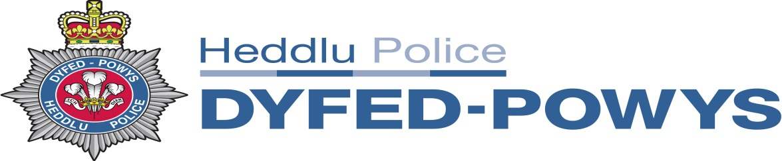

Information sheet relating to the General Election December 2019

The purpose of this document is to ensure that Candidates and Agents are aware of the Guidance and Information available to them, as well as highlighting a number of issues that have arisen previously which resulted in police intervention. This advice is issued in order to reduce the need for police intervention in this important democratic process.

The Electoral Commission website www.electoralcommission.org.uk has a wealth of information for anyone involved in the election process and includes advice for professionals, political parties, candidates and agents.

Of particular relevance is the ‘Guidance for candidates and agents’ and the ‘Code of conduct for campaigners: electoral registration, postal voting, proxy voting and polling stations’

The Representation of the People Act 1983 defines most offences for UK Parliamentary elections, local government elections and for electoral registration and postal voting issues across the UK. Other legislation, such as that relating to bribery, making a false statement, forgery, using a false instrument, conspiracy to defraud and common law provisions may also apply.

If you have any queries or wish to seek clarification in respect of any aspect of the election, the Returning Officers and other avenues for advice are able to assist; it is imperative that if you have any concerns you obtain advice before you act.
The following are examples of issues that have previously been reported to and investigated by the police:
- Treating – before, during or after an election directly or indirectly give or provide any food, drink, entertainment or provision in order to influence any voter to vote or to refrain from voting;
- Personation – whereby an individual votes as someone else;
- Imprints - An imprint must be added to printed election material and must contain the name and postal address of the printer, the promoter of the material and any person on behalf of whom the material is being published. Where the material is printed on a one-sided document, the relevant details must appear on the face of the document. Where the material is printed on more than one side, the required details must appear on either the first or last page of the document;
- False statements of fact about the personal character or conduct of a candidate in order to affect the return of that candidate. It is up to the person making the posters, leaflets or statements to make sure that what is being said is factually correct, if you quote material that is in the public domain you may need to identify what efforts you have made to check its authenticity;
- Postal voting - registration of fictitious names to the electoral register, registration of the same individual at different addresses, falsifying proxy documentation, threats and intimidation in premises such as care establishments
The Dyfed-Powys Police single point of contact for alleged Election malpractice is:
Paul Callard, who can be contact via email: Election.spoc@dyfed-powys.pnn.police.uk
Current Community Tensions & Personal Safety
This campaign will overwhelmingly be influenced by continued debate between the Leave and Remain campaigners and as such community tension has risen across the country. Whilst nothing serious has been reported to the UK Police forces, we may reach a tipping point and this could change at any time.

Political debate and discussion underpins our democratic process and the freedom to engage in debate and disagree with others is a key component of public life.
Sometimes, it can go too far. When it does, it may lead to harassment, intimidation or threatening behaviour and, in some circumstances, may constitute criminal offences.

The election period places a number of pressures on candidates. This will include greater scrutiny on them and their political standpoint resulting in candidates and agents being subject to heightened public exposure.

For the majority of candidates, and for most of the time, these pressures will not impact on their personal safety. However, there have been occasions where candidates have been exposed to unacceptable levels of harassment and intimidation which can have a significant psychological impact on candidates and those close to them.

In some cases, these behaviours and actions have reached the criminal threshold with the worst examples unfortunately having led to violence and injury.

To date UK policing has already seen an increase in the number of low level threats and abusive messages sent to MPs both in person and by social media platforms.

The following are a few of the pertinent safety advice messages which we would urge all candidates and agents to consider:-

- When out and about in the public domain be mindful of your surroundings, try to keep visible in public areas and as best possible be accompanied when canvassing for votes

- Always have your mobile phone with you and charged, contact the police through the normal channels if you feel concerned about your personal safety

- Consider whether you will you be happy for personal contact with the local neighbourhood officers. This is more for reassurance and slow time advice if required. If you are holding large canvassing events please consider notifying their local neighbourhood officers for awareness

- If a candidate experiences a safety issue then we will treat individually and consider some of the measures we use for Operation Bridger and normal policing business

- Consider whether you will be happy for candidates and agents personal details to be added to Police IT systems for the period of the campaign to enhance the policing response to any harassment, intimidation or threatening behaviour

Further information, support and guidance have been provided in the following leaflets produced by the Electoral Commission including “When it goes too far” and “Joint guidance for candidates in elections”.

