TO LET

A PARCEL OF GRAZING LAND

AT

ASHDALE LANE, LLANGWM

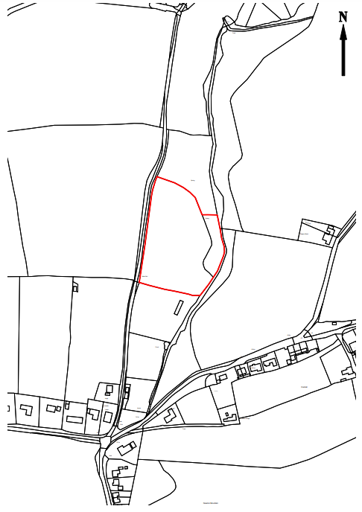

Pembrokeshire County Council informs all prospective tenants that whilst every care is taken in the preparation of these particulars it does not guarantee their accuracy and shall not be held to form any part of the contract. All measurements and areas are approximate and given as a guide only. The Council will bear no responsibility for expenses incurred in viewing the property which may be sold or withdrawn without notice. The Council does not give, and the Council’s employee’s have no authority to make or give, any representation or warranty whatsoever in relation to the property. The Council does not undertake to accept the highest or any offer and no offer should be made which is calculable by reference to the offer of another party.

LAND AT ASHDALE LANE, LLANGWM, PEMBROKESHIRE

DESCRIPTION
A parcel of grazing land within Pembrokeshire County Council’s County Farm Estate is to be let on a tenancy agreement.

LOCATION
The land is located on the outskirts of the villages of Llangwm and Hill Mountain .

THE LAND
This extends to approximately 3.00 acres shown outlined in red on the attached plan.

TERM
The land will be let on the standard County Council agreement for a term of 3 years

RENT
Tendered rents should be in excess of £850 per annum

Applicants are asked to indicate the annual level of rent that they would be prepared to offer.
This is to be shown on the enclosed application form.
The rent will be payable quarterly in advance on the 1st day of the agreement.

VIEWING

The land can be viewed from the public highway.

CLOSING DATE

No later than 12 noon on Friday April 29th 2022



BY INFORMAL TENDER

LAND AT ASHDALE LANE, LLANGWM

The letting will be on a 3 years agreement.

The Council reserves the right not to accept the highest or any tender

Tender Offer

I/We………………………………………………………………………………………

Of…………………………………………………………………………………………

……………………………………………………………………………………………

Hereby Offer £……………………………………………. Per annum (figures)

……………………………………………………………………………per annum (words)

For the Tender

Signed……………………………………………………..

Dated ………………………………………………………

Completed tender form be emailed to properyhelpdesk@pembrokeshire.gov.uk before
the closing date.

